**First Medium Blog on Auto ML: Pycaret**

Hello folks,This is my first blog in medium as we all know that this is a lockdown time and we have to stay at home and utilize this priceless time in new utilities,enhancing skills and learning new technologies.So today I will tell you the concept of Auto ML and in this concept the first library I am going to describe is **‘PYCARET’.**

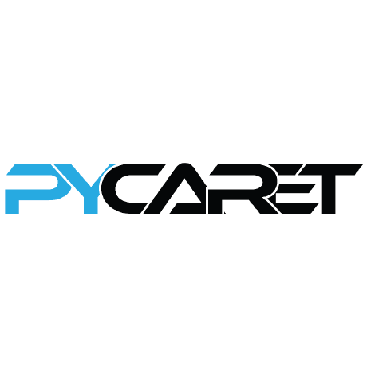

So **What is Auto ML Basically?**

Automated machine learning (AutoML) basically involves automating the end-to-end process of applying machine learning to real-world problems to generating ML solutions for the data scientist without having to do endless searches on data preparation, data cleansing, model selection,Model building that are actually relevant in the industry.

Now we will discuss about the library use for AUTO ML.

**What is PyCaret?**

PyCaret is an open source, low-code Auto ML(end-to-end machine learning) library in Python that aims to reduce the cycle time from hypothesis to insights and make data scientists more productive in their experiments and allows them to reach conclusions faster due to far less time spent in coding. PyCaret is essentially a Python wrapper around several machine learning libraries and frameworks such as scikit-learn,XGBoost, Microsoft LightGBM, spaCy and many more.Through the use of PyCaret, the amount of time spent in coding experiments reduce drastically (up to 20 folds).

PyCaret is simple, easy to use and deployment ready. Comparatively other open source machine learning libraries, PyCaret is a low-code solution which is simple in design and easy to use and we have to write only few lines of code to do end to end process of ML.The architecture of PyCaret is deployment ready which means all steps and dependencies in an experiment are automatically orchestrated and saved into a pipeline that can be deployed into production or could be transferred into another environment to run at scale.

Recently released, PyCaret supports Classification and Regression in supervised learning and Anomaly Detection, Clustering, Natural Language Processing and Association Rule Mining in unsupervised learning. It has approximately 70+ automated open source algorithms and over 25+ pre-processing techniques that are fully arrange. PyCaret supports automatic hyperparameter tuning, automatic feature engineering and feature selection. It also has rich analytical capabilities with over 40 visualizations to analyze machine learning models. Keeping updating in the area of deep learning,AI and Neurals.

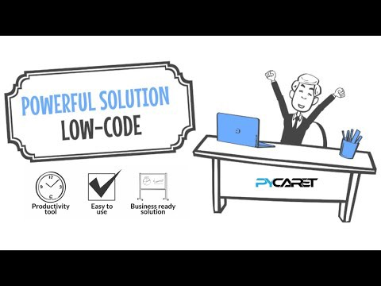

**What is the necessity of PyCaret?**

PyCaret is free and open source library which is easy to install and work in both locally and cloud and there is no limitation of use. Anyone can use that library like data scientist,data analyst,students learning ML,small or midsize company.

**How to start Pycaret?**

You can become an early adopter and download the pre-release build (pycaret 0.0.60 at the time of this post) using pip installer.These are the steps:

pip install pycaret

Load the Libraries and data

Choose the Target Variable

Data preprocessing though codes

choose data problem

Create Mode

Finalize model and compare with various models on various metrics through cross validaton.

So it is very simple to use as it has very less codes to do end to end process and build a model and also compare the performance with various modeles on kfold cross validation and various metrics.

Thanks a lot to read this.I will keeping updating my stories which will help you to learn things in such a easy manner.